(Approx. 952 words)

How to Find a Lost Document and Other Filing Tips
By Nancy DeMarte, 1st Vice President, Sarasota PC Users Group, FL
August 2013 issue, PC Monitor
www.spcug.org
ndemarte (at) Verizon.net

I suppose you’re thinking this could never happen…until it does. You have a large number of folders full of documents and photos on your computer. One day you need to find a letter that you wrote and saved a week ago, but can’t remember what name you gave it or which folder you saved it in. Here are some ways to find that document:
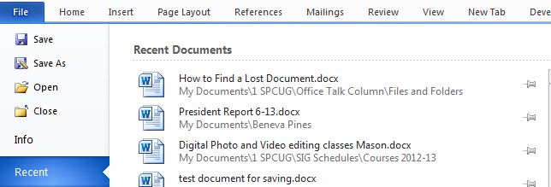
Look in your Recent Documents list: Open Word 2010 or 2007 and click File, and you will see a list of documents you opened recently. If you haven’t opened more than about 20 documents since you saved the letter, it will be on the list. If you find the letter, you can open it from the Recent Documents list. But before you do that, it’s a good idea to take note of its “path,” so you’ll know exactly where it’s stored. The path of a document file in Word 2010 is shown below its name in the Recent Documents list. It is represented by a string of folders, starting with the largest folder, My Documents, and ending with the sub-folder in which the document is stored. As shown, the path for this article is “My Documents\1 SPCUG\Office Talk Column\ Files and Folders.” In Word 2007, the path is missing in the Recent Documents view, but with a few steps, you can find it. Open Word 2007 and click the Office button to open the Recent Documents list. Click a recent document to open it. Then click Office button – Save As. In this window the path of the document appears in the address bar across the top. The last folder in the string of folders is where the document is stored.

You can keep or “pin” any Recent Document to the list for easy future access by clicking the pushpin icon next to it. You can also right click a recent document in Word 2010 and select “Remove from list.” Recent files lists exist in most 2070 and 2010 Office programs.

Search your computer: In Windows 7, click the Start button at the left end of the taskbar, then type in the search box one or more words which you guess are part of your lost letter’s name. If your guess is correct, the letter should appear in the Files list and can be opened from there. Sometimes, however, a Windows 7 search does not find files stored too deeply in sub-folders. Windows 8 offers a more targeted search. Open the Charms from the Start Screen and click the category of item you’re looking for, such as Mail or, in this case, Files. Then type your search words in the Search box. This tool searches inside all levels of sub-folders in the category and returns a list of possibilities. It searches not only file names, but also the body of the document.

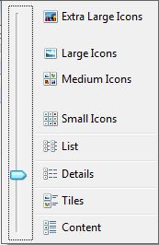
Make use of File Views: The contents of any folder on the computer can be viewed in various ways, but some views fit certain kinds of files better than others. It’s easiest to find a document in a file list using the Details view, which is a list which includes File Name, Date Modified, File Type, and Size. A photo is best viewed as an Icon or Tile, which shows a thumbnail of the photo, its name, and file size. To change the view of a file list in Windows 7, open a folder, then click the Views icon at the right end of the menu bar. By moving the slider, you can preview how different views affect your list before making your selection.

If your letter does not appear in Recent Documents and is not found with a Search, you can open My Documents and scroll to the bottom of the list of folders to see unfiled documents. If it isn’t there, then open a sub-folder where you guess it might be. Set the view to Details, and sort the list by Date Modified, which will put recently opened files at the top of the list. To sort, click the heading of the Date Modified column. Reverse the sort order by clicking the heading again. File names sort alphabetically; dates chronologically.

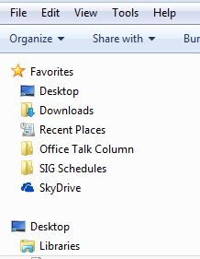
Add folders to your Favorites: Much like the Favorite websites list you keep in your Internet browser, Windows provides a convenient spot for you to park folders that you open frequently. Open Libraries. In the Explorer Window, at the top of the navigation pane on the left, you’ll see a section called Favorites. A few folders are listed there by default, but you can customize this list with your own folders. I keep my SIG Schedules and Office Talk Column folders there because I open them frequently, and because opening a Favorite folder takes only one click. To add a folder to Favorites, make it visible in the main Explorer window (but don’t open it), then click and drag it left onto the word Favorites, or use Copy and Paste. A Favorite folder is synchronized with the original one. Whenever you make a change to files in the original folder, the change will also appear in the Favorites version and vice versa.
File Management is one of the most difficult skills to master in a Windows environment. And each new version of Windows changes the system just enough to cause confusion.

The more you understand how files and folders are stored and organized on your computer, the more control you’ll have of your documents and other important files. You won’t have many lost documents, either.

